**Experiment Number - 2**

**Student Name:** ANIKET KUMAR **UID:** 20BCS5306

**Branch:** CSE **Section/Group:** 20BCS_WM-703 / B

**Semester:** 5th **Date of Performance:** 23rd Aug, 2022

**Subject Name:** DAA LAB **Subject Code:** 20CSP-312

**1. Aim/Overview of the practical:** Code implement power of function in O (log n) time complexity.

Given two integers **x** and **n**, write a function to compute xn. We may assume that x and n are small and overflow doesn’t happen.

Write a program to calculate power (x**,** n)

**2. Task to be done/ Which logistics used:**

Visual Studio Code (IDE).

**3. Program Code:**

#include <iostream>

using namespace std;

float myPow(float x, int y) {

if(y == 0)

return 1;

float temp = myPow(x, y / 2);

if (y % 2 == 0)

return temp*temp;

else {

if(y > 0)

return x*temp*temp;

else

return (temp*temp)/x;

}

}

int main() {

int x,n;

cout << "Enter value of x and n :";

cin >> x >> n;

cout<<x<<" raised to the power "<<n<<" is "<<myPow(x, n);

return 0;

}

**4. Output :**

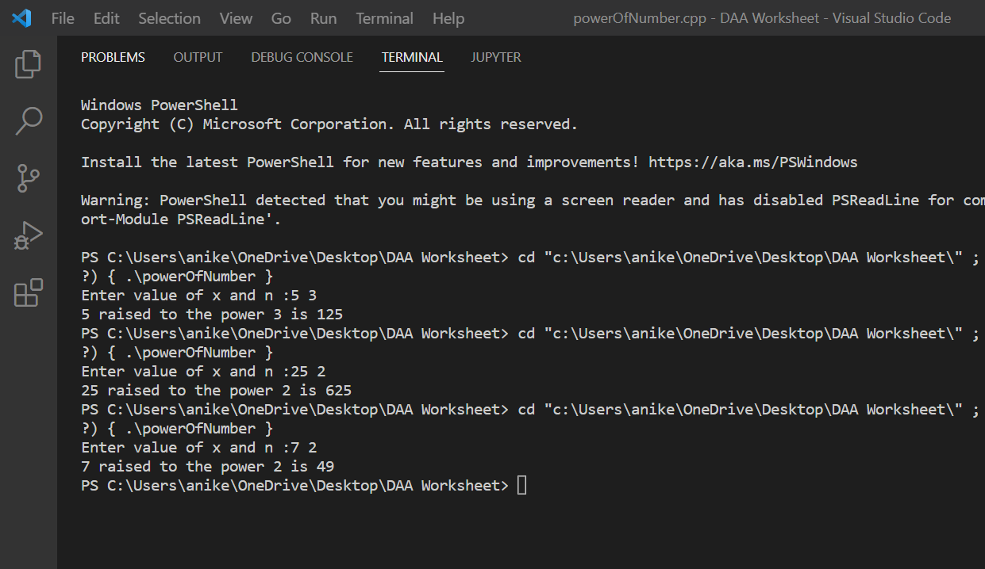

**Learning outcomes (What I have learnt):**

1. I have learnt how to write program in C++.
2. I have learnt about conditionals(if-else, switch-case) and loops(for loop, while loop, do-while loop).
3. I have learnt about arrays and strings.

**Evaluation Grid (To be created as per the SOP and Assessment guidelines by the faculty):**

|  |  |  |  |
| --- | --- | --- | --- |
| Sr. No. | Parameters | Marks Obtained | Maximum Marks |
| 1. |  |  |  |
| 2. |  |  |  |
| 3. |  |  |  |
|  |  |  |  |